WILLIAM THOMSON (LORD KELVIN)
Quick Facts
William Thomson was a British physicist, mathematician and engineer. He was born on the 26th June 1824 in Belfast, Ireland and died at the age of 83. He is buried next to Newton in Westminster Abbey.  Thomson was brought up in strict Presbyterian fashion by his father. He attended Glasgow University from the age of 10 and started university-level work at 14. Later, Thomson entered Cambridge University and graduated as the 2nd Wrangler. His association with Glasgow University was enduring; he was the Professor of Physics for 53 years  Thomson was a keen rower and cornet player. He was renowned for being maverick and extremely self-confident; he is often described as being hubristic. Thomson was a twice-married man, yet only six of his children survived infancy. |  |  | 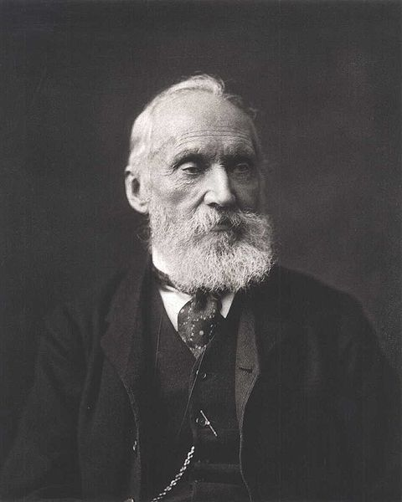
Thomson entered the Royal Society in 1851. He was knighted in 1866 and elevated to the peerage in 1892 as Lord Kelvin.

During his lifetime, Lord Kelvin published more than 600 scientific papers and filed a total of 70 patents.

Numerous physical phenomena and concepts are named after Kelvin, the most notable being the absolute temperature scale.

'Kelvin'  Coat of Arms |  | Significant Physics-related discoveries
 | 1848  1851  1852 | Defined the absolute temperature scale.  Published ideas which ultimately led to the 2nd law of thermodynamics.  Observation of the Joule-Thomson effect.

Notable Quotes
“When you can measure what you are speaking about and express it in numbers, you know something about it.”

“The more you understand what is wrong with a figure, the more valuable that figure becomes.”

“All science is either physics or stamp collecting.”

“X-rays will prove to be a hoax.”

A snapshot of his other discoveries
Thomson developed a complete system for operating a submarine telegraph. It included the mirror galvanometer and the siphon recorder. This system was used to successfully lay the first transatlantic telegraphic cable. | 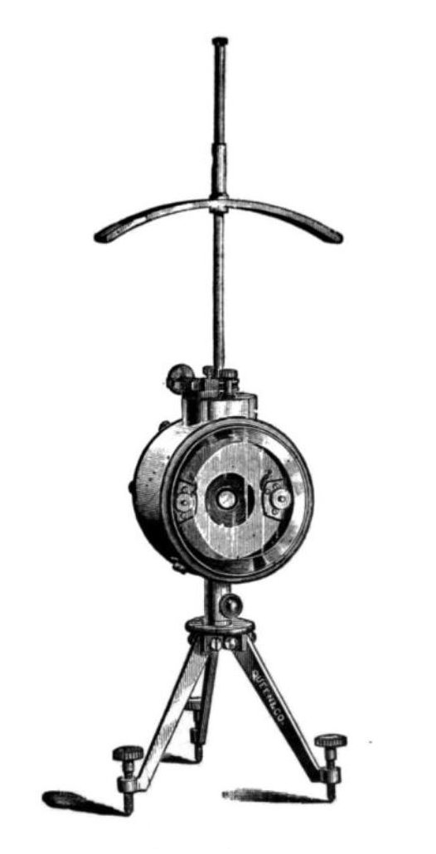
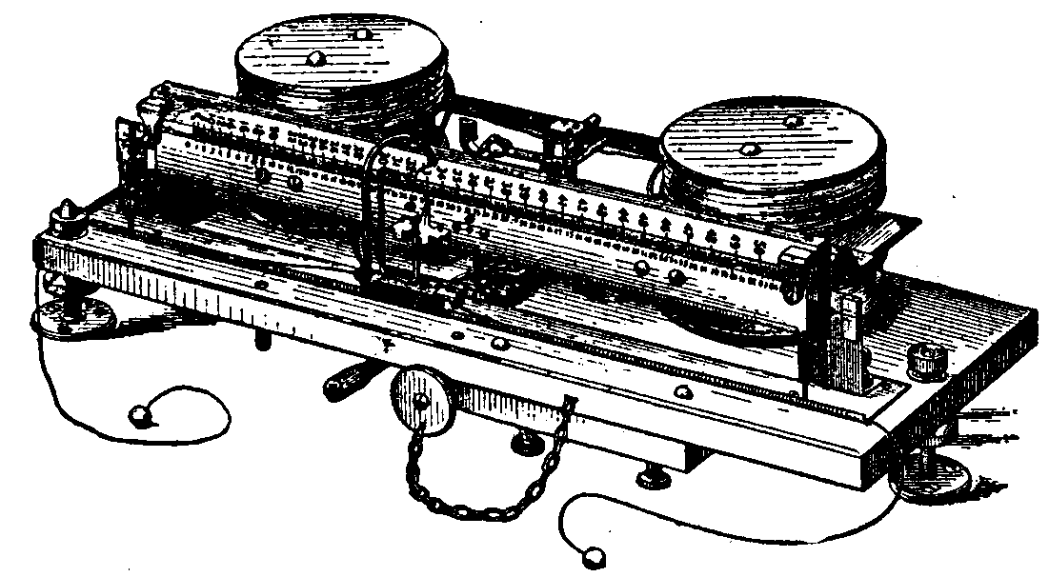 | Thomson invented the Ampere balance which, for the time, enabled the precise measurement of electric current. However, due to accuracy issues, the Watt balance is now used instead.
A final thought …
Kelvin worked out an improved method for measuring the depth of the sea, using piano wire and a narrow-bore glass tube, stoppered at the upper end. While experimenting with this invention, he was interrupted one day by his colleague James Prescott Joule. Looking with astonishment at the lengths of piano wire, Joule asked him what he was doing, "Sounding," said Thomson. "What note?" asked Joule. "The deep C (sea)," replied Thomson.

Bibliography

http://en.wikipedia.org/wiki/William_Thomson%2C_1st_Baron_Kelvin
http://scienceworld.wolfram.com/biography/Kelvin.html
http://www-groups.dcs.st-and.ac.uk/~history/Biographies/Thomson.html
http://www.todayinsci.com/K/Kelvin_Lord/Kelvin_Lord.htm
http://physicsworld.com/cws/article/indepth/32214
http://en.wikipedia.org/wiki/File:Lord_Kelvin_photograph.jpg
http://www.physics.gla.ac.uk/Physics3/Kelvin_online/Kelvin_society/Kelvin_arms.gif
http://upload.wikimedia.org/wikipedia/commons/d/d8/Thompson_mirror_galvanometer.jpg
http://upload.wikimedia.org/wikipedia/en/0/0b/Lord_Kelvins_Ampere_Balance.png

